University of the People

CS4404 Advanced Networking and data security

Unit 2 Written Assignment 2

Anonymous Student

**Introduction**

All packets are captured during the interaction with UOP portal.

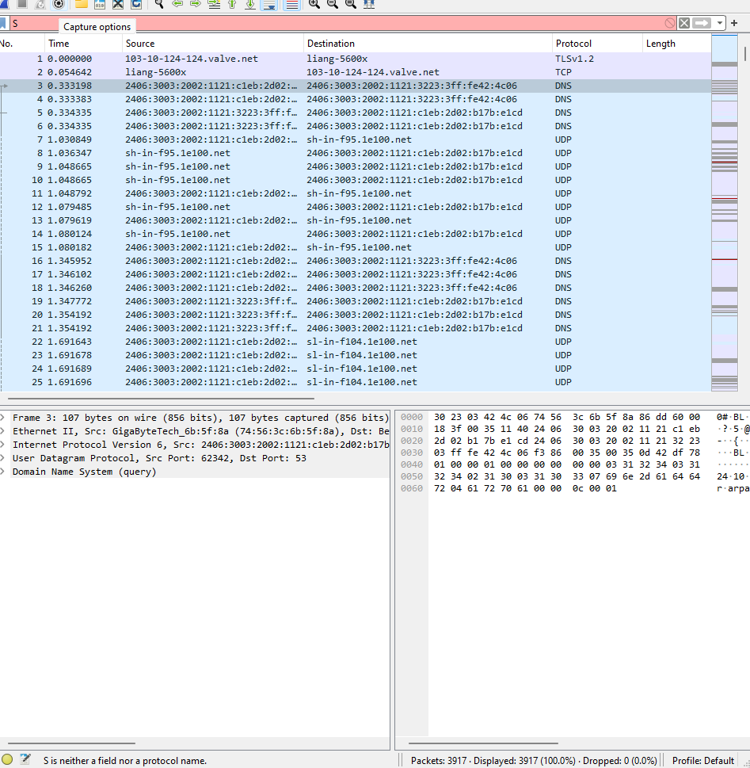

**Google** is pinged.

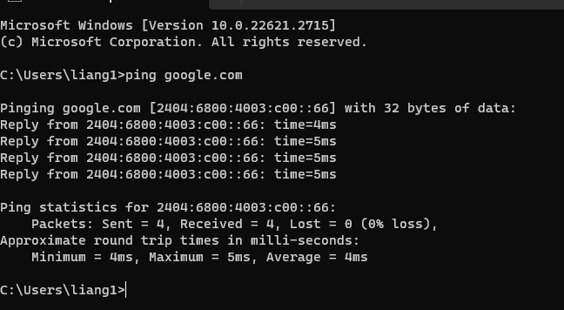

Stoped the package capture

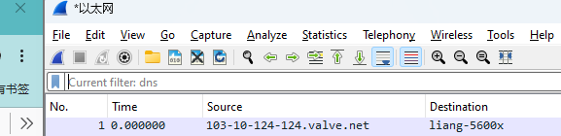

a. What is the total number of network packet protocols seen in the packet capture? Name at least five of them with relevant screenshots.

Total packets = 3917

b. Filter for HTTP packets. How many HTTP packets can you see (take screenshot)?

c. Filter for DNS packets. How many DNS packets can you see (take screenshot)?

d. Filter for ARP packets. How many ARP packets can you see (take screenshot)?

e. Filter for TCP packets. How many TCP packets can you see (take screenshot)?

**HTTP** packets are 4.

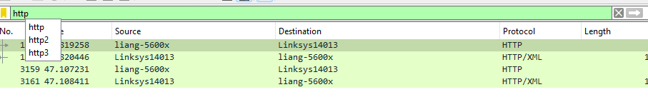 

**DNS** packets = 314

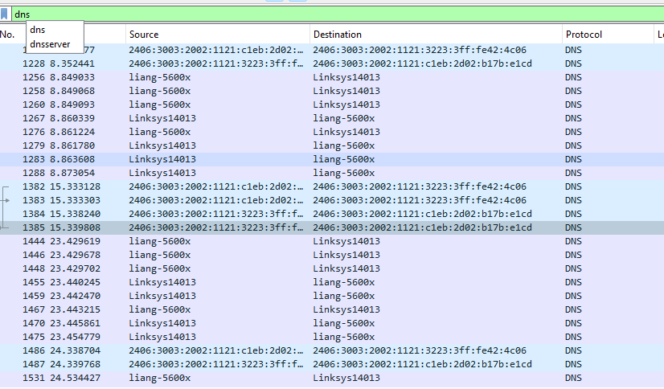



**ARP** packets are 0.

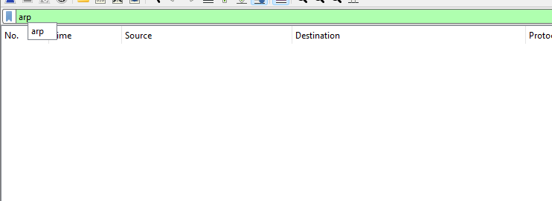

**TCP** packest are 3428

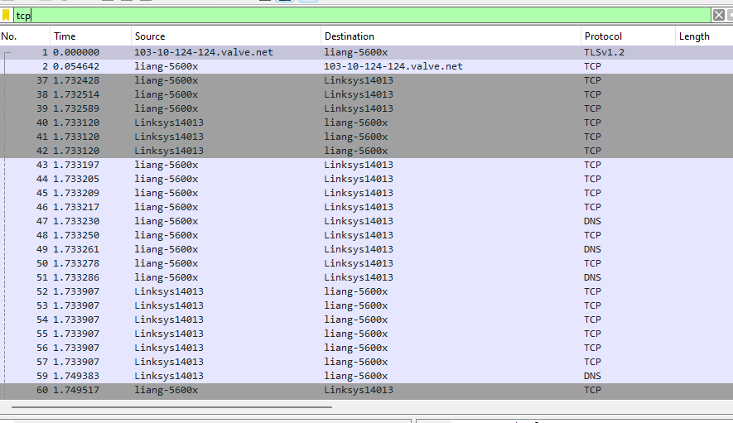



**Conclusion**

Overall, through this practice, I have successfully installed the Wireshark that is the network pakcge inspection tool(*What Is Wireshark and How to Use It | Cybersecurity | CompTIA*, n.d.). By utilizing such a tool, I am able to capture and statrt to analyse the packges incoming and outgoing for my PC.

**Reference**

*What Is Wireshark and How to Use It | Cybersecurity | CompTIA*. (n.d.). Retrieved November 19, 2023, from https://www.comptia.org/content/articles/what-is-wireshark-and-how-to-use-it

*Wireshark Cheat Sheet - Commands, Captures, Filters, Shortcuts & FAQs*. (n.d.). Retrieved November 19, 2023, from https://www.comparitech.com/net-admin/wireshark-cheat-sheet/

*Wireshark User’s Guide*. (n.d.). Retrieved November 19, 2023, from https://www.wireshark.org/docs/wsug_html_chunked/index.html